.

[[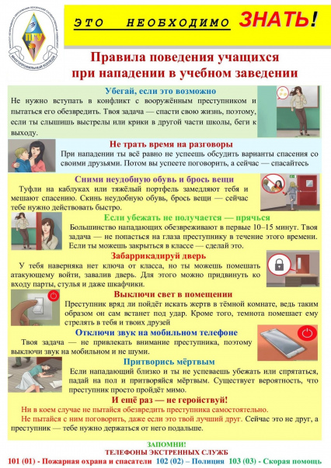](https://vk.com/doc292230424_602543695?hash=IBdD1yIpXIUHp6oklxjEFFs5kAVGG4a9YvwRWEbdRn4&dl=HxXXr2OFNyS1zyOOHyoeSJlki0BfkBGkqHlfMvcv6Z8)](https://vk.com/doc292230424_602543695?hash=IBdD1yIpXIUHp6oklxjEFFs5kAVGG4a9YvwRWEbdRn4&dl=HxXXr2OFNyS1zyOOHyoeSJlki0BfkBGkqHlfMvcv6Z8" \t "_blank)